1. Home Page when customer are not added to the database (http://localhost:8080/CustomerManagement/list)Graphical user interface, text, application

   Description automatically generated
2. Add Customer to the directory (http://localhost:8080/CustomerManagement/addcustomer)Graphical user interface, application, Word

   Description automatically generated
3. When customer details are added to the directory (http://localhost:8080/CustomerManagement/list)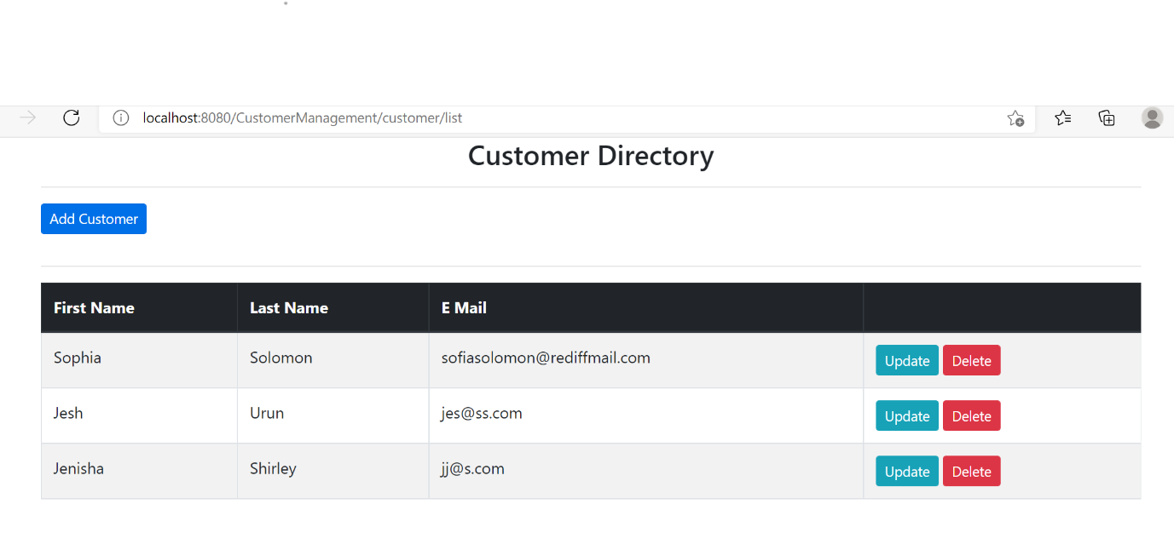
4. Delete Customer details Graphical user interface, text, application

   Description automatically generated
5. Update Customer details (http://localhost:8080/CustomerManagement/updatecustomer?customerid=11)

